**ILAYARAJA**

**E-mail:** [Ram@infigroup.com](mailto:Ram@infigroup.com)

**Phone:** 201 489 3500 Ext 303

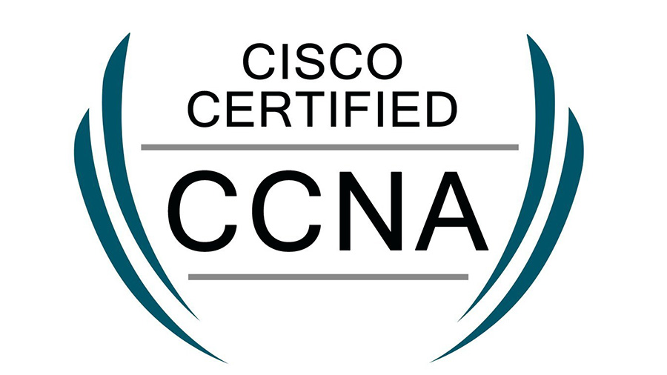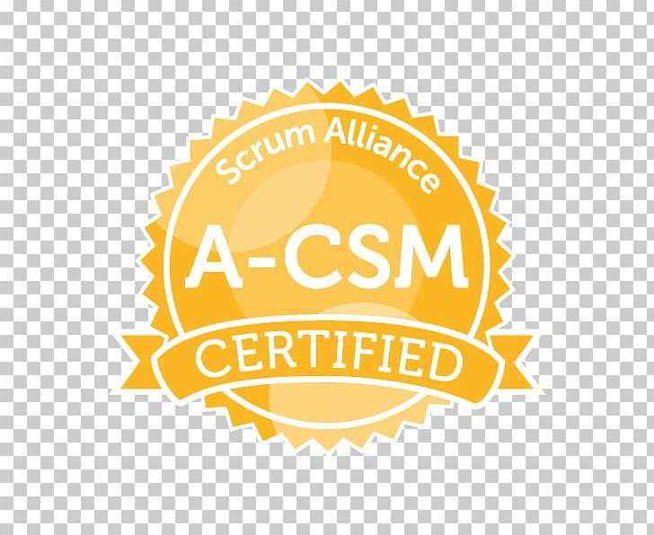

**EXPERIENCE SUMMARY**

* Highly skilled, Career-intent, Self-motivated professional with over 18+ years of experience in the software industry looking for a position in the field of **DevOps**.
* Result-oriented individual with proven ability to implement standards, procedures, and processes that improve overall **DevOps processes**.
* Designed and implemented CI / CD pipeline using **Jenkins**, **Bash Scripting** for **Python, Java and Angular-based** applications helping project team develop, test, and deliver the software packages fast & reliably.
* Proficient in cloud infrastructure provisioning using **Terraform**, configurations, and management of various managed services like **Compute Engine, Storage, Relational Database, VPC, Security Groups**, Firewalls, Load Balancing, DNS, Autoscaling, Containerization, **Kubernetes** on **Amazon Web Services (AWS) and Google Cloud Platform (GCP)**
* End-to-end product deployment ownership at **on-premises as well as cloud infrastructure**.
* Expert in Installing and configuring Continuous Integration tools, **Docker, Kubernetes, and Salt Stack** from scratch.
* Integrated GitHub, Jenkins, Terraform, and Salt to **automate the build process, infrastructure provisioning, and application deployment process**.
* Setting up system-level and application-level **Monitoring & Alerting using Prometheus**.
* Branching/Labelling/Merging/tagging, Clone, and rebasing and other SCM setup & configuration work on source code management tools like **GitHub and Bitbucket**
* Managed different environments like **Dev, Dev QA, and Ops QA** for various releases and designed instance strategies at **on-premises and AWS Cloud**
* Strong Project Management skills in achieving project objectives on time following various **Project Management methodologies**.
* Understood and followed the best practices of **Agile Methodologies**
* Thorough knowledge of the complete software development life cycle (SDLC).
* Excellent communication and leadership skills.

**PROFESSIONAL EXPERIENCE**

**TECHNICAL SKILLS**

|  |  |
| --- | --- |
| **Operating Systems** | **Linux (Centos 7, Oracle Linux 8),** Windows |
| **Programming Languages** | **Python**, Java 5 |
| **Frameworks** | Flask, Tornado |
| **Scripting Languages** | **Python Scripting, Bash Scripting**, Servlets, JSP, JavaScript, CSS, JQuery |
| **Virtualization** | **VMWare, KVM** |
| **Containerization** | **Docker, Kubernetes(K8S)** |
| **Cloud** | **Amazon Web Services (AWS), Google Cloud Platform (GCP), OpenStack** |
| **Design Patterns** | Core Java (GOF) and JEE Patterns |
| **Database** | **Postgres SQL and MySQL** |
| **IDE, Profilers & Testing** | Eclipse, MAT, Junit |
| **Protocols & Specification** | TCP/IP, SNMP, RIP, OSPF, HTTP, DNS, CIFS, HLS |
| **CI/CD Tools** | **Jenkins, Artifactory** |
| **Monitoring Tools** | **Prometheus, Grafana** |
| **Infrastructure/Configuration Tools** | **Salt Scripts, Terraform, Ansible** |
| **SCM Tools** | GitHub, Bitbucket |
| **Certification** | **Cisco Certified Network Associate (CCNA)**  Sun Certified Java Professional (SCJP 5.0)  Sun Certified Web Component Developer (SCWCD)  **Certified Scrum Master (CSM)** |

**EDUCATION**

**Bachelor of Engineering** April 2003 Aggregate: 72%

Specialization: Computer Science and Engineering

**Thiagarajar College of Engineering, Chennai, India**

**AWARDS AND ACTIVITIES**

* Awarded by CISCO for the following key accomplishments.
  + Received SPARC awards 2 times while working on MIB Test Tool application development.
  + Efficiently handled critical customer issues for ‘LEVI STRAUSS & COMPANY’
  + Handled critical customer issues and enhancements bug fixes in CIFS AO
* Travelled to San Jose for Toolapalooza 2008 representing the MIB Test Tool for a couple of weeks.

**PROJECTS SUMMARY**

**Client: Synamedia and Cisco Systems, MA**

**#1 Open Media Distributions (OMD) – April 2017 to May 2023**

OMD is a next-generation Content Delivery Network (CDN) solution. OMD has different sub-products OMD Core is the core of CDN which caches and streams video traffic to clients over HTTP/HTTPS. OMD Director is the control plane application used to set up, configure, and manage CDNs. OMD Monitor is the monitoring application that monitors all the nodes, which are part of the CDN on system and application levels.

OMD Insights is the analytics application for the CDN Solution. It collects the CDN transaction logs, processes them, and makes meaningful dashboards and reports to customers.

**Responsibilities:**

* Requirements collection from Customer
* Analysis and Feature development
* Bug/**Defect fixing and Ops QA Testing**
* **Upgraded the Base OS from CentOS7.9 to Oracle Linux 8.5, Oracle Linux 8.6**
* **Automated the OS Upgrade process using Shell (BASH) Scripting.**
* Written **Salt Deployment Scripts** to upgrade the **Kubernetes v1.17 to v1.25**
* Written **YAML Templates** for deploying the **ConfigMaps**, **Pod Deployment**, Mounting Volumes, Persistent Volume, and Persistent Volume Claim and **Service on Kubernetes**
* Deployed and Configured **Jenkins and Jobs for builds systems, and CI/CD pipeline**.
* Deployed and Configured **OMD Test Environments using Terraform on VMWare and AWS**
* Bring up Nessus Scanner on **AWS to execute the Nessus Security Scan to identify the vulnerabilities**.
* Deployed **EC2 VM Instances on multiple AWS Regions**, Zones and Created and **Applied Security Groups to EC2 Instances to secure the VMs access on AWS**, Elastic IP reservation, Configured IAM roles and **Uploaded Custom OS Images to AWS for OMD**, Monitor and report the resource usage using **AWS Cost Management Service**.
* Designed and deployed the **OMD on AWS for a Customer POC.**
* Customer support for deployments
* Provide solutions to customer issues.
* Provide technical guidance to the team members.
* Overall Delivery Responsibility

**Technologies / Tools Used: AWS, Python, Java, Salt Stack, Docker, Kubernetes, Splunk, Postgres DB, MongoDB, CentOS7.9/Oracle8.6, VMWare, Jenkins, Terraform, JIRA, Artifactory, Prometheus, Grafana and GitHub (SCM)**

**#2 Video Load Emulator (VLE) on Kubernetes (POC) – Jul 2016 to Mar 2017**

**Customer: Cisco Systems**

Cisco Video Load Emulator is currently deployed as a virtual machine on VMware/OpenStack platform. We have done this POC to build expertise within the group on the Containerization/Docker/Kubernetes platform. We have successfully completed the POC and demoed it to the customer

**Responsibilities:**

* Bring up Kubernetes Cluster on OpenStack Cloud.
* Drive the team to complete the POC.

**Technologies/Tools Used: Docker, Kubernetes, Open Stack, AWS**

**#3 Virtualized Video Platform (V2P) on OpenStack – Jul 2016 to Mar 2017**

**Customer: Cisco Systems**

Cisco Virtualized Video Platform Controller is the base open and extensible platform to Orchestrate, Manage and Operate Media Functions throughout multiple heterogeneous cloud and virtualization platform based on characteristics of specific video microservices, facilitates deployment, and manage both Cisco and third-party video data plane applications (such as encoders, packagers, and recorders) in the data center cloud environment– abstracted from the underlying infrastructure such as VMware, OpenStack, or Docker.

Cisco Virtualized Video Platform Controller also provides an SDK for third-party application integration and custom workflow creation, to chain virtual video functions together. This enables the rapid deployment of new services, such as Live, VOD, or cDVR, to OTT consumers while maintaining multi-vendor flexibility

**Responsibilities:**

* Bring up Private Cloud based on OpenStack
* Worked on Features and bug fixing for V2P on OpenStack
* **End-to-End V2P workflow testing on OpenStack.**

**Technologies/Tools Used: Python, OpenStack, Heat Templates, and Bootstrap.**

**#4 Media Origination System (MOS) on OpenStack – Aug 2012 to Jun 2016**

**Customer: Cisco Systems**

Media origination provides critical functions required to capture, store and originate media for multi-screen consumption. The media origination primarily provides the enabling functions in the media data plane. The Ultimate goal of the Media Origination system is to address all of the major media service use cases such as linear, VOD, Time-shifted TV, and Cloud DVR as a fully automated cloud-based service.

**Responsibilities:**

* Bring up Private Cloud based on OpenStack
* Build Expertise on OpenStack and provide a solution to use it on MOS Product
* Make the MOS Product run on OpenStack
* Designed and developed Orchestration Features for node deployments
* Created HEAT YAML template to deploy MOS product on OpenStack
* Investigate, Debug, and provide solutions for the MOS deployment issues
* Supporting/Debugging issues with the team for OpenStack Installations
* End-to-End MOS workflow testing on OpenStack
* Automated test cases to run on daily images

**Technologies/Tools Used: Python, OpenStack, Heat Template, and VM Orchestration**

**#5 Cisco Axiom Middleware – Open Cable Applications Platform (OCAP) – Feb 2011 to Jul 2012**

**Customer: Cisco Systems**

Cisco Axiom is a Middleware stack in the STB domain that implements the OCAP specifications. Good knowledge of the Axiom middleware stack. Good working experience on the modules like Tuning, DVR, EAS, and HN modules

**Responsibilities:**

* Triaging the day-to-day issues reported by CIT and SVT team
* Analyzing and providing solutions for the issues tracked on the CDETS for Axiom
* Work with the application team and provide support/suggestions for the new feature and provide implementation on the middleware stack.
* Provide technical support to the new engineers and do the knowledge sharing to get familiar with the STB domain and the process in place.
* Provide support to LAB engineers to set up new head-end.

**Technologies/Tools Used: Java, STB, EAS, DVR, Home Networking, CA Handler**

**#6 Common Internet File System Application Accelerator (CIFS AO) – Sep 2009 to Jan 2011**

**Customer: Cisco Systems**

Cisco WAAS is a solution that optimizes the performance of TCP-based applications operating on the Wide Area Network (WAN) environment. WAAS combines WAN Optimization, TCP Optimization, Data Redundancy Elimination (DRE), and Application protocol acceleration as a single appliance.

CIFS AO is one of the application optimizers in the Cisco WAAS, which optimizes the CIFS/SMB traffic flows between client and server. CIFS/SMB protocol is used between Windows/Linux systems to access the File/Print Shares.

**Responsibilities:**

* Played a key role in getting Knowledge Transfer of the CIFS component.
* Involved in sustaining each of the respective modules in the CIFS component.
* Supported customer queries/cases on day to day basis and point of contact for critical customer issues.

**Technologies/Tools Used:** JDK1.5, Eclipse 3.3, MAT

**#7 Cisco SNMP MIB Test Tool (MTT) – Mar 2006 to Dec 2008**

**Customer: Cisco Systems**

SNMP MIB is tested to verify its functionality and compliance, implemented in the SNMP agent, Cisco IOS. MIB is manually tested before the tester hand-codes the ATS scripts written in TCL. MIB tester spends lots of time doing manual testing. Once the tester completes the manual testing, he/she starts building the test automation scripts from the scratch and spends a considerable amount of time coding and testing the scripts.

MIB Test tool helps the testers in doing the manual testing (functional testing) and automation of the ATS script (in TCL) generation by providing a visual IDE that comes integrated with functions like MIB Browser to open a MIB, SNMP Console to do the object queries like GET/GET NEXT/ SET/GET BULK/WALK, support for multiple SNMP Managers like Scotty, Net-SNMP and a local NMS (SNMP4J), Instantiated MIB Tree, MIB compliance test using MIB Toaster, Interactive Terminal to connect to the UUT and execute the Cisco IOS CLI command and verify the object query output, Record the SNMP queries and Cisco IOS CLI commands executed and use it for building the MTT Project - set of procedures, SNMP/CLI commands, variables, pass/fail criteria added by the user, wizard-based TCL generation, wizard-based ATS job submission and so on. MTT maximizes the MIB tester’s productivity by helping him to complete the ATS scripting much faster.

**Responsibilities:**

* Requirement analysis
* Writing Software Functional Specification (SFS)
* Designing the Software, Writing Software Design Specifications (SDS),
* Submitting the SFS & SDS to review the process
* Addressing the review comments
* Integrated the open-source Terminal Console with MIB Test Tool
* Implemented the Instantiated MIB Tree module
* Implemented the Variable Definition Module
* Implemented TCL Generation Module
* Addressed the issues of HOT1 and HOT2 image
* Implemented the job status feature
* Implemented opening all the imported MIBs feature
* Released the MTT to production
* Demo on MIB Test Tool given to MIB Testing Team
* Addressing customer queries and issues
* Do follow-up releases to production.

**Technologies/Tools Used:** JDK1.5, Eclipse RCP 3.3, SWT, JFACE, XML, XSD, Multi-Threading, JNLP, Axis web services, LDAP, JProbe, JUnit, Jtest, Windows XP, Clear Case

**#8 Cisco SNMP MIB Release Tool (MRT): - Jan 2009 to Aug 2009**

**Customer: Cisco Systems**

SNMP MIB Release Tool is a Java and Perl-based Application that supports the IOS Release Team to get the list of New Cisco MIBs, Modified Cisco MIBs, and Standard MIBs that should be released with the IOS Release process. MIB Release Process will be Streamlined to make sure the MIBs are released perfectly with IOS Release on CCO. MIB Release Tool GUI was developed using Java, JSP, and Servlets. The MIB Release Tool back-end process was developed using Perl.

**Responsibilities:**

* Quickly understand the MII Script and got complete knowledge of MII Script
* Understood quickly Single Source and Re-directory projects architecture
* Modified the MII Script so that it works with Single Source and Re-directory projects architecture

**Technologies/Tools Used:** Java, JSP, and Servlets

**Company: L-Cube Innovative Solutions, Chennai, India**

**Duration: Jan 2004 to Feb 2006**

**#9 Health Care (HCare) – Jan 2004 to Feb 2006**

Health Care product provides the total online solution for large and medium Health care providers. It consists of modules such as EMR, Scheduling, Patient Login, Bills, Claims, Tickets Resolver, and Reports. I have been involved in Scheduling, Reports, Tickets Resolver, and EMR.

**Module: Appointment Scheduler**

Scheduling hospitals/doctor’s appointments is the main theme of this module. Doctors can view, book, cancel, Lock, Unlock, and Reschedule their appointments singly or bulky. Different type of interface helps doctors and doctors’ office to do their work effectively. Different kind of reports is available to view the productivity of the doctors.

The scheduler is the Interface through which the Doctors schedule and manipulate their Appointments. Appointments can be booked, modified, Searched, and can be canceled in the Scheduler Interface. Moreover, the Scheduler page can be customized to the specific user and can be modified to suit particular requirements. The Scheduler page consists of many links through which the user can get a sophisticated interface to work with it.

**Module: Ticket Resolver**

The tickets resolver module helps the Health Care providers to post their problems as tickets. They can view, reply and close their tickets. It allows them to take reports based on the problems reported. It helps them to track their patient’s billing-related requests.

**Module: Reports**

Generating reports according to the client’s requirement and upgrading the existing version to embed new business logic. This module is very useful to the client to analyze his business status and make decisions accordingly. This report module plays an important role to market our product. We have developed a custom template by which any kind of complex business logic can be easily converted into a report.

**Responsibilities:**

* UI Designing, Implementation, and Unit Test.
* Sustenance and bug fixing.

**Technologies/Tools Used:** Java, JSP, Servlets, CSS, HTML, JDBC, Apache, and Tomcat

**#10 Electronic Medical Record (EMR) – Jan 2004 to Feb 2006**

Electronic Medical Records (EMR) can effectively replace paper works of practices. Patient visit records are electronically maintained here. This also features mail forwarding, record forwarding, record status maintenance, and intelligent retrieval of patient information from records. A special scribble object is available to write/scribble the patient notes directly into the computer using a scratch pad and pen. A doctor can order/review Internal and external lab test, referral request, patient prescription, etc., Print modules print the patient charts in chronological order, an enormous number of outpatient Treatment Request forms is available for different insurance company category which is used to get authorization from insurance directly.

**Module: Scan Module**

This module deals with attaching scans to the patient chart under different categories. These scans may lab results and personal information of the patient. Scans in the form of multi-page Tiffs can be edited, attached to a patient, or forwarded to another category. And also scans can move from one category to another category. Scans will be displayed based on encounters & lab also

**Responsibilities:**

* UI Designing, Implementation of scan module, and unit test
* Sustenance and bug fixing

**Technologies/Tools Used:** Java, JSP, Servlets, CSS, HTML, JDBC, Apache and Tomcat